

Mohan Raj Nandagopal

300759596

Portfolio Website

Table of Contents

**Introduction**3

**Navigation Bar**3

**Colors**4

**Typography** 5

**Wire frame** 6

**Branding** 11

Introduction:

This portfolio site is created to let the viewer know about me , my experience working in different technologies and as well as some of the applications that I have worked on. This site helps the viewers to have a idea about my skill set and the services that I will be able to help them with.

I have also provided the viewers with the feature to connect with me thorough some popular social networking sites like facebook, Linkedin , Google + and Github. Site also provides the my contact information to the viewers which will help them to contact me personally as well.

**Navigation Bar :**



Active page is displayed in blue

List of pages at the right side of the page

Company logo at the left side of the page

The navigation bar is made with the Company logo on the left side of the bar and the list of pages on the right side. There are five pages linked to the navigation bar (i.e) Home, About me, Projects, Services, Contact me.

The active page is highlighted with a rectangular box with a blue background.

**Colors:**

List of colors used in the website.

|  |  |  |
| --- | --- | --- |
| **Color Name** | **Hex Value** | **Color Sample** |
| White | #FFFFFF |  |
| RGB (24,26,28) | #181A1C |  |
| Black | #000000 |  |
| Light Blue 2 | #B2DFEE |  |
| Light Steel Blue 1 | #CAE1FF |  |

**Typography :**

Below table shows the list of fonts and their sizes at each section in the home page.

|  |  |  |  |
| --- | --- | --- | --- |
| **Section** | **Size** | **Font** | **Color Code** |
| A | H1 | Sans-serif | #181A1C |
| B | H3 | Sans-serif | #181A1C |
| C | 17px | Sans-serif | #181A1C |
| D | H2 | Sans-serif | #181A1C |
| E | H4 | Sans-serif | #181A1C |

**Screenshot of Home page:**

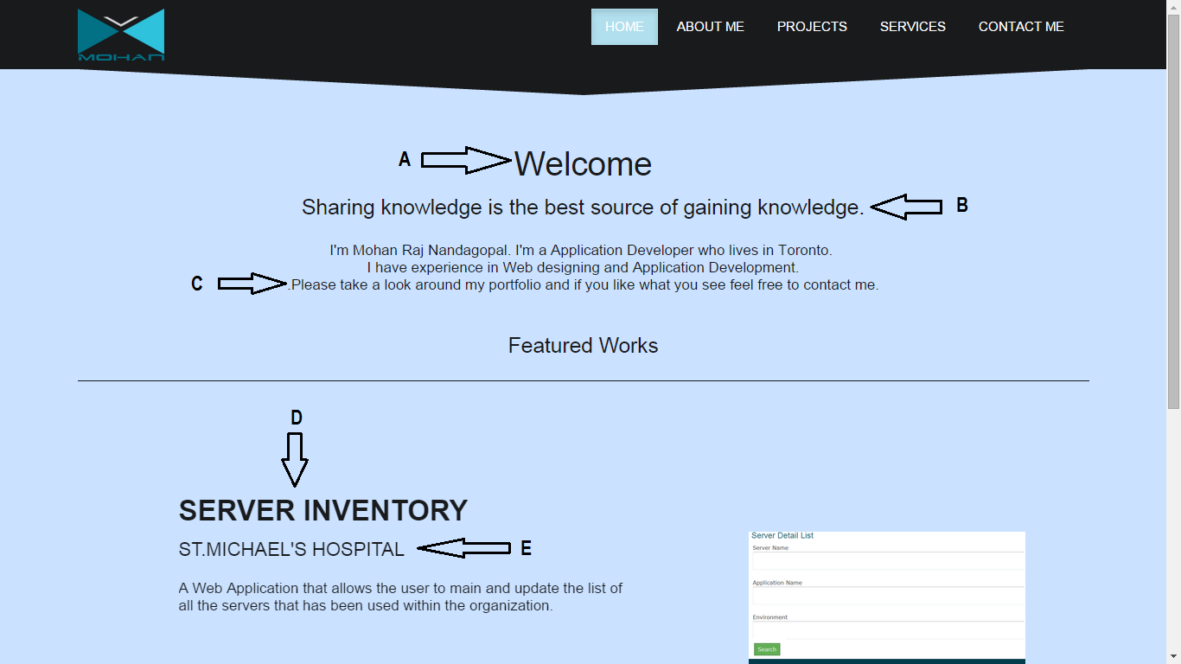

**Wire Frame:**

**Home Page :**

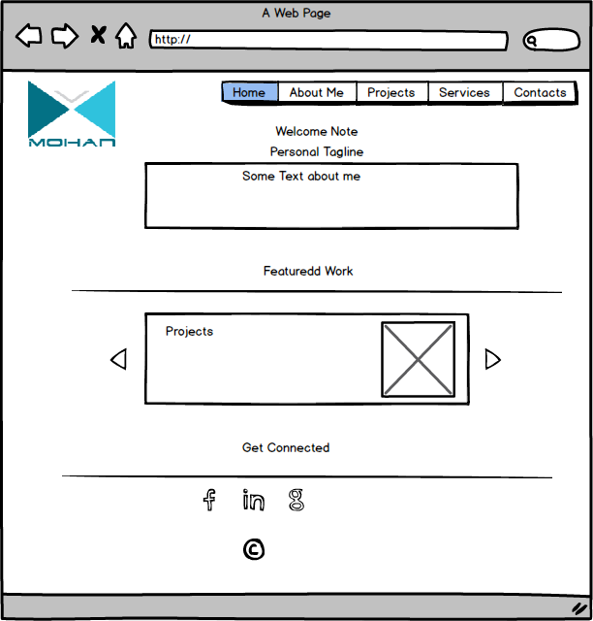

**About Me:**

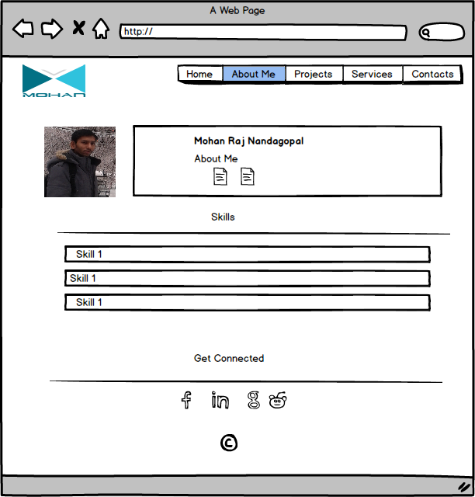

**Projects:**

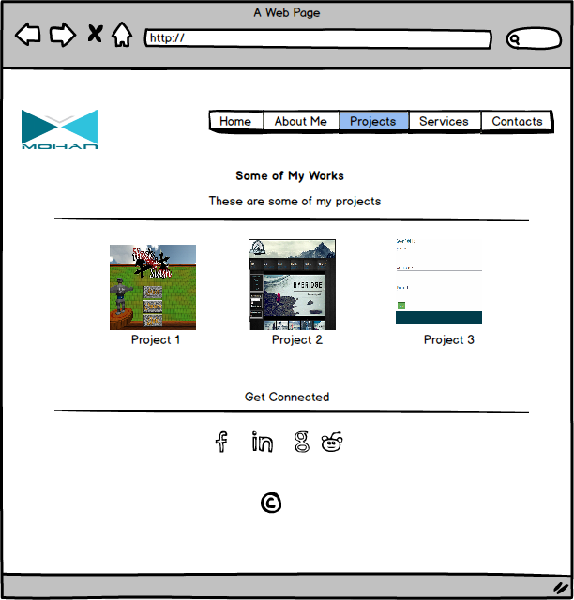

**Services:**

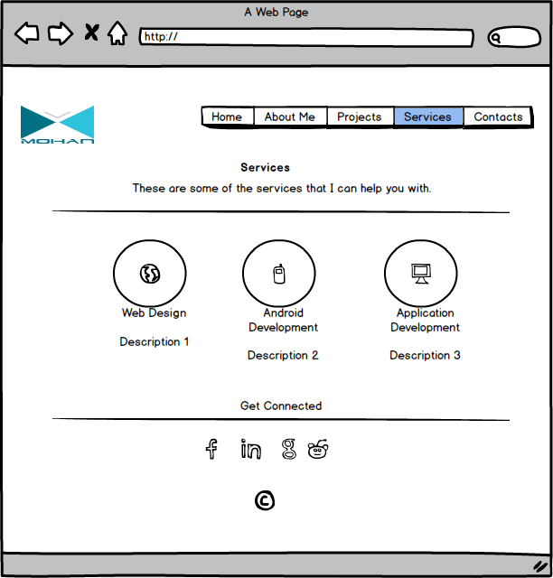

**Contact Me:**

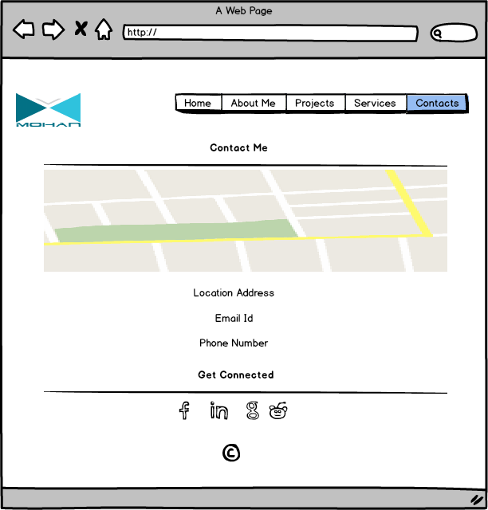

**Branding :**

**Company Logo**



The following table describes the list of colors used in the logo

|  |  |  |
| --- | --- | --- |
| **Color Name** | **Hex Value** | **Color Sample** |
| RGB(3,113,133) | #037185 |  |
| RGB(47,194,221) | #2FC2DD |  |
| RGB(228,229,232) | #E4E5E8 |  |

**Home page screen capture:**

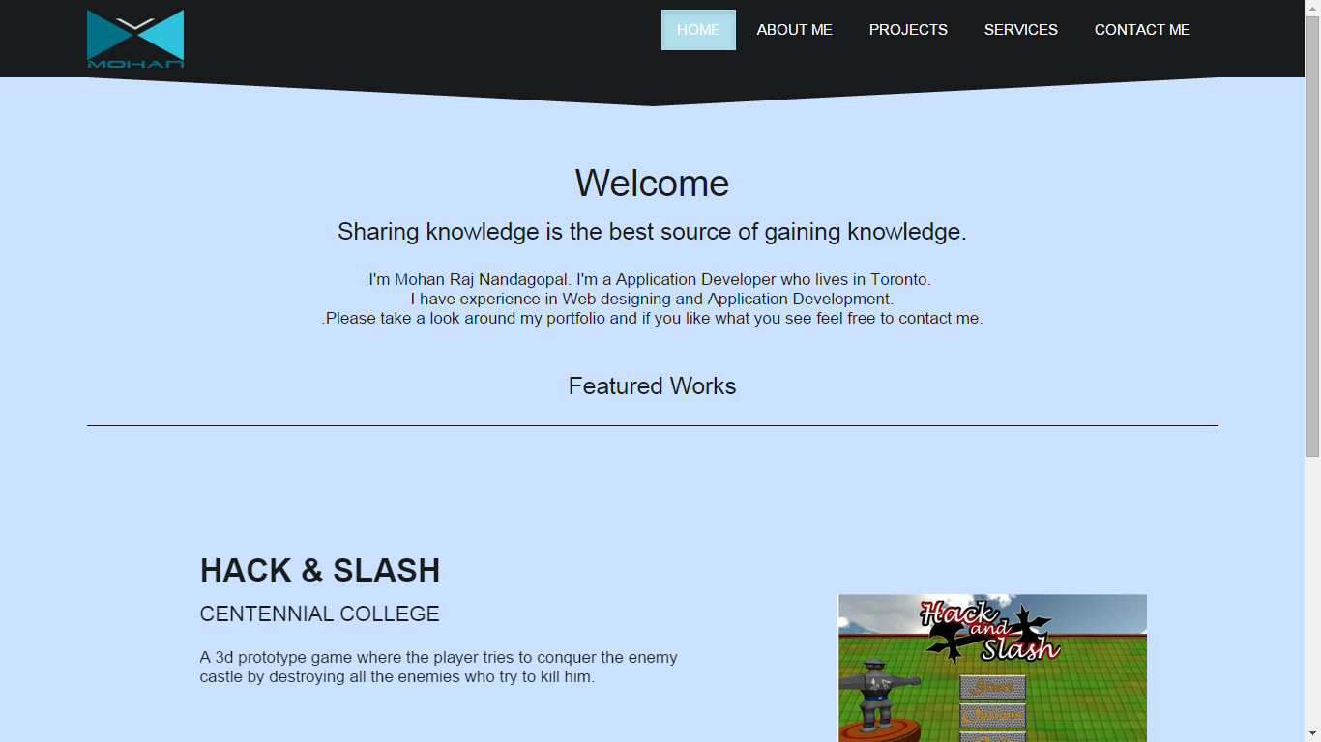

**About me :**

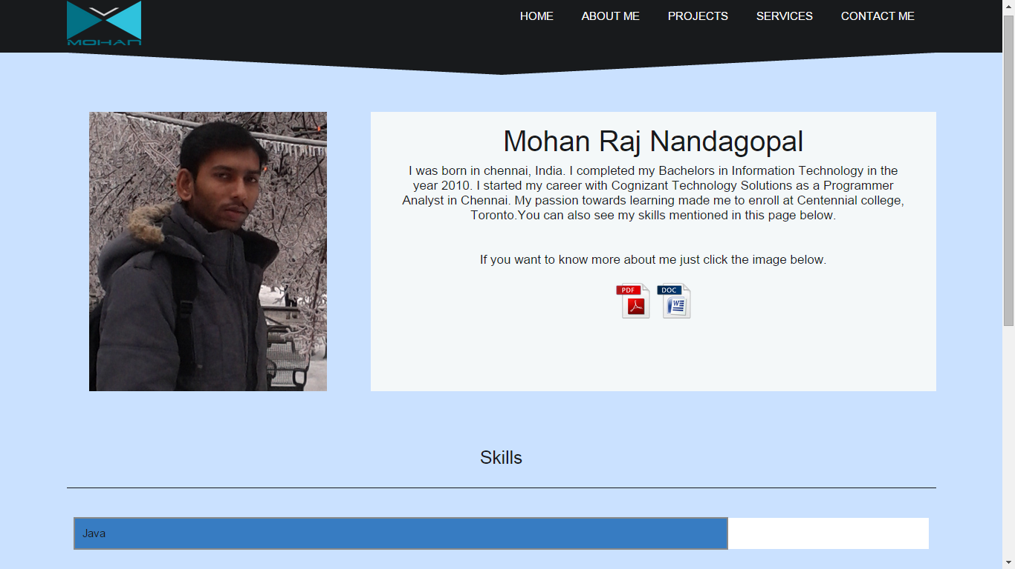

**Projects:**

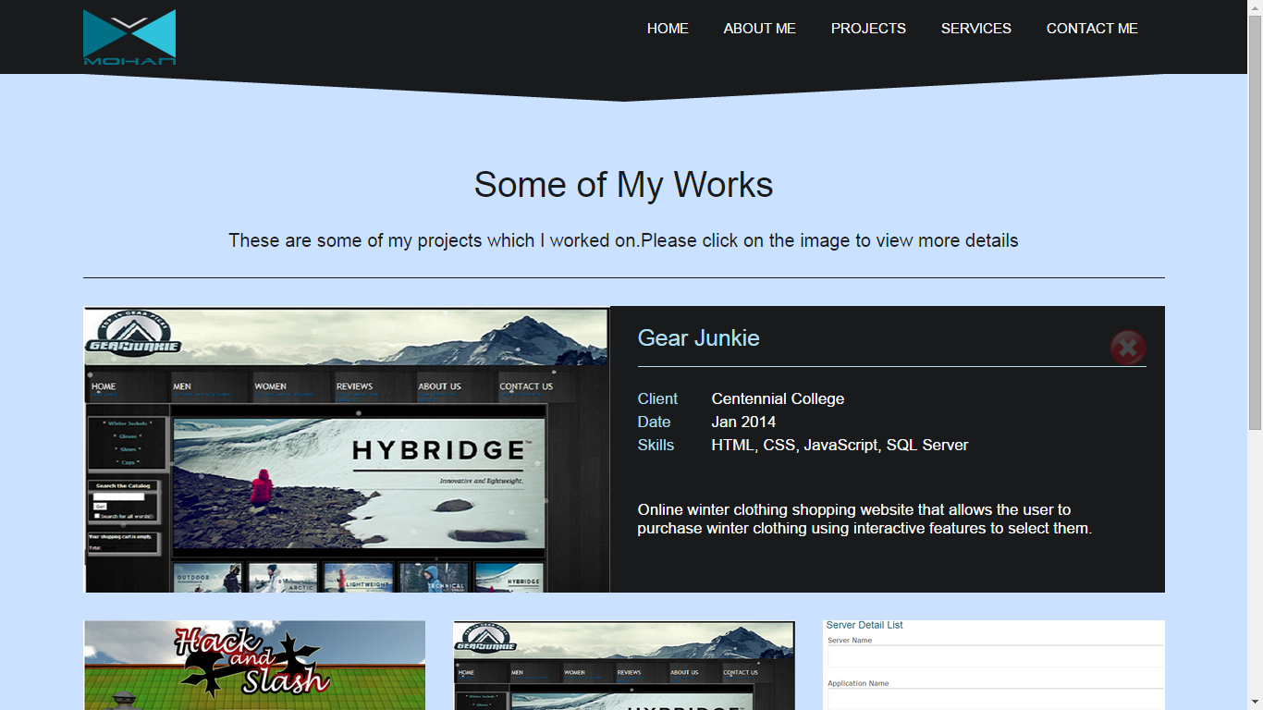

**Services:**

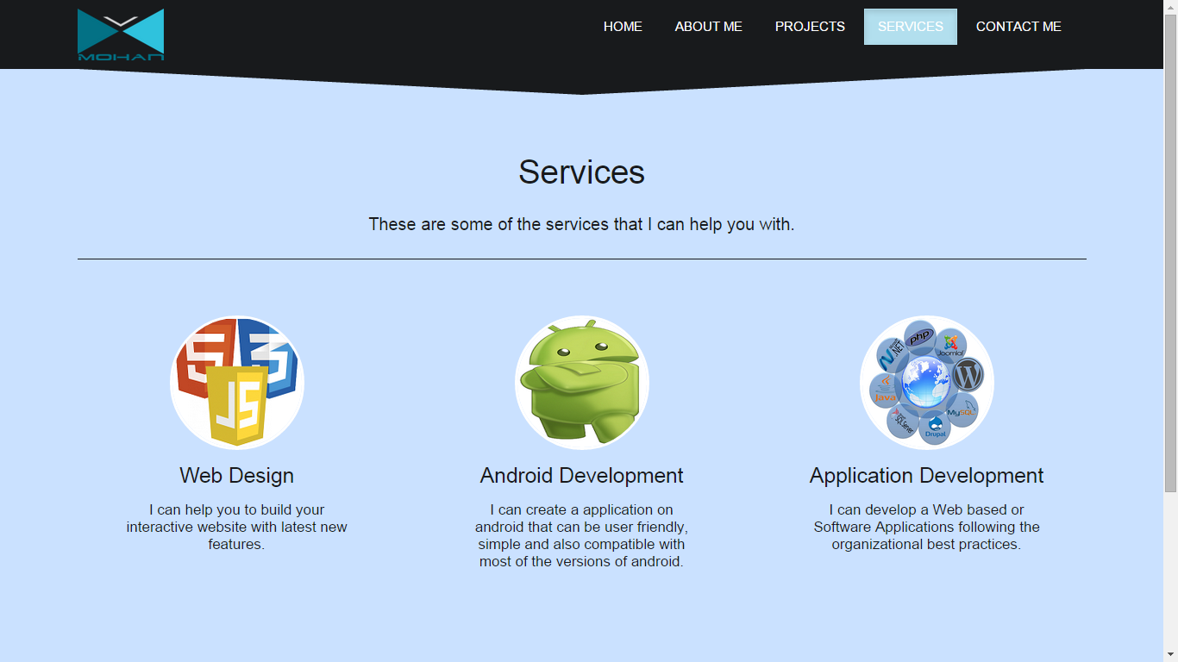

**Contact Me:**

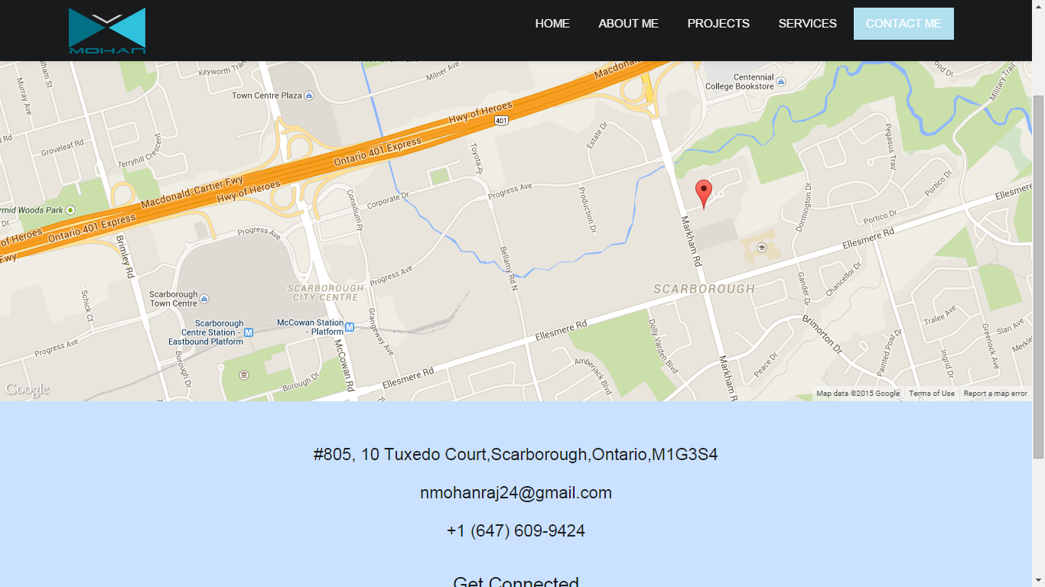

**Get connected section:**

